**Traffic Guide**

**I．Visiting Time参观时间**  
D1: June 12th (Thursday) 6月12日（星期四）09:00-16:30  
D2: June 13th (Friday) 6月13日（星期五）09:00-16:30  
D3: June 14th (Saturday) 6月14日（星期六）09:00-16:30

**II． Transportation Guide交通指南**

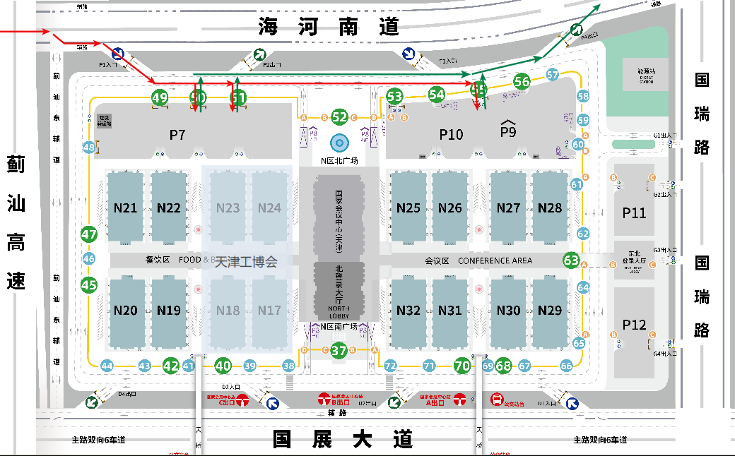

**National Convention and Exhibition Center (Tianjin) guide map**

**国家会展中心（天津）导览图**

1. **Airport → Venue Guide机场→展馆指南**

The straight-line distance from Tianjin Binhai International Airport to the venue is approximately 35 km. Upon arrival, we recommend taking a taxi or public transit (bus/metro) to the National Convention and Exhibition Center (Tianjin).

天津滨海国际机场到展馆的直线距离约35公里。抵达机场后，建议您搭乘出租车、公交地铁前往国家会展中心（天津）。

**Venue address:** No. 888 Guozhan Avenue, Jinnan District, Tianjin.

**展馆地址：**天津市津南区国展大道888号。

**Taxi:** Approximately RMB 67

**出租车：**约67元

**Metro route:** Take Line 2 from "Binhai International Airport Station" (towards Caozhuang), transfer to Line 10 (towards Yutai) at Yudongcheng Station, then transfer to Line 1 (towards Shuanghe Bridge) at Finance University Station, and alight at National Convention and Exhibition Center Station.

**地铁路线：**乘坐地铁2号线“滨海国际机场站”（曹庄方向），在“屿东城站”换乘地铁10号线（于台方向），在“财经大学站”换乘地铁1号线（双河桥方向），在“国家会展中心站”下车。

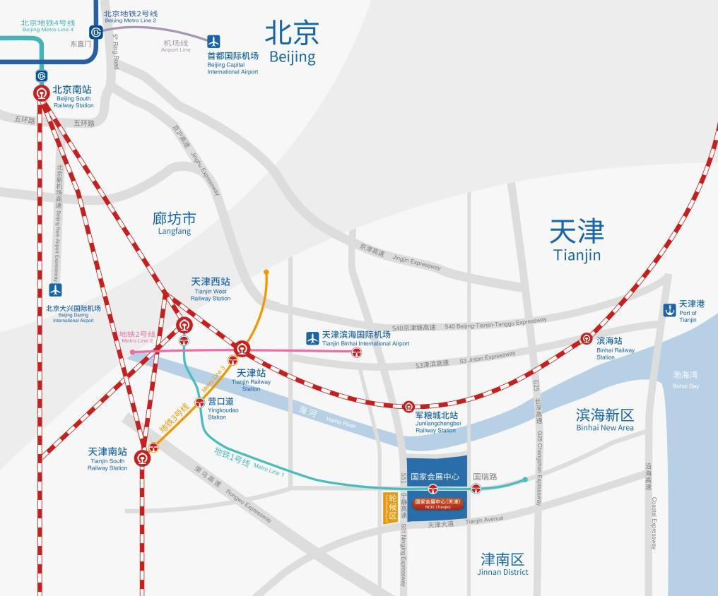

1. **Railway Stations → Venue Guide火车站→展馆指南**

**2.1 Tianjin Railway Station天津站**

抵达天津站后，您可搭乘出租车或地铁前往国家会展中心（天津）。

**Taxi:** Approximately RMB 64

**出租车：**约64元

**Metro route:** Take Line 3 from "Tianjin Railway Station" (towards South Station), transfer to Line 1 (Shuanghe Bridge direction) at Yingkoudao Station, and alight at National Convention and Exhibition Center Station.

**地铁路线：**乘坐地铁3号线 “天津站”（南站方向），在“营口道站”换乘地铁1号线（双河桥），在“国家会展中心站”下车。

**2.2 Tianjin West Railway Station天津西站**

抵达天津西站后，您可搭乘出租车或地铁直达到国家会展中心（天津）。

**Taxi:** Approximately RMB 101

**出租车：**约101元

**Metro route:** Take Line 1 (Shuangqiaohe direction) directly from Tianjin West Railway Station Metro Station to National Convention and Exhibition Center Station.

**地铁路线：**天津西站地铁站（乘坐1号线双桥河方向），在“国家会展中心站”下车。

**2.3 Tianjin South Railway Station天津南站**

抵达天津南站后，您可搭乘出租车或地铁到国家会展中心（天津）。

**Taxi:** Approximately RMB 119

**出租车：**约119元

**Metro route:** Walk to "Tianjin South Railway Station" and take Line 3 (Xiaodian direction), transfer to Line 1 (Shuanghe Bridge direction) at Yingkoudao Station, then alight at National Convention and Exhibition Center Station.

**地铁路线：**步行至“天津南站”乘坐地铁3号线“天津南站”（小淀方向），在“营口道站”换乘地铁1号线（双河桥），在“国家会展中心站”下车。

**III、Metro Guide轨道指南**

Line 1 provides direct access to the venue. Our extensive rail transit network ensures comfortable and secure arrival. Please remember to disembark at "National Convention and Exhibition Center Station".

地铁一号线可以直达展馆，四通八达的轨道交通网络可以让您舒适安全地抵达场馆，记得在“国家会展中心站”下车哦！

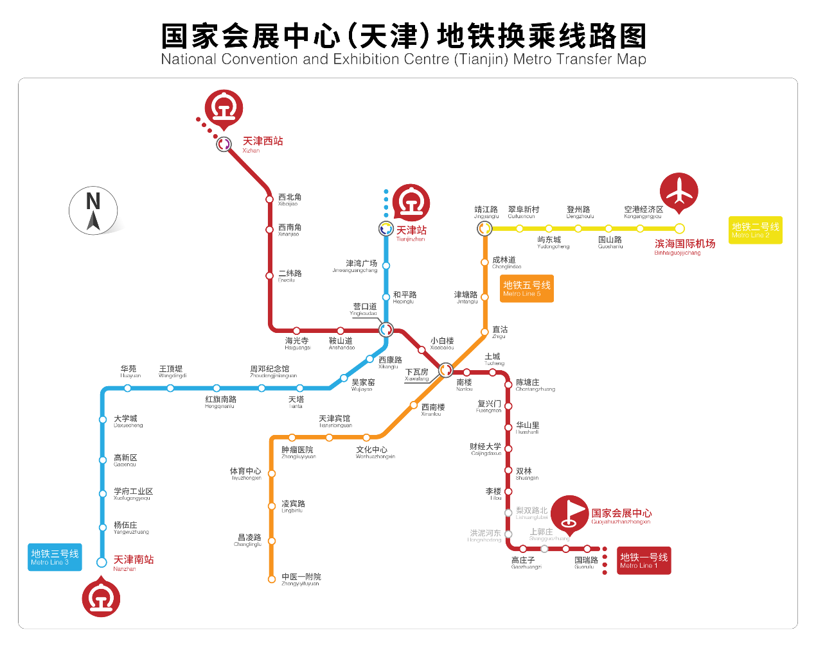

**IV、 Bus Guide公交指南**

Multiple bus routes serve the venue:  
212 West Line, 224, 226 East Line, 226 West Line, 217, 204, 219, 228, 309. All routes terminate at National Convention and Exhibition Center Bus Station.

展馆附近有多条公交线路可供选择，212路西线、224路、226路东线、226路西线、217路、204路、219路、228路、309路，以上线路均在国家会展中心公交站设终点站，出行无忧。

**V、Navigation Guide导航指南**

Long press the QR code to directly locate venue entrances and obtain precise navigation instructions.

长摁二维码，直接定位展馆入口，提供更加精准的导航信息。

